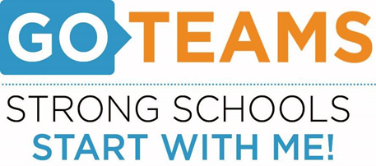
MEETING NOTICE
School | Date | Time | Location
John Lewis Invictus Academy | Tuesday, August 30,2022 | 5:15 pm | JLIA YouTube Channel

Notice Prepared By: B. Kirkpatrick Date Posted: 8/24/22
Meeting Agenda
(agenda may be amended)
I. Call to Order
II. Roll Call; Establish Quorum
III. Action Items
A. Approval of Agenda
B. Fill Vacant Positions (if applicable)
C. Fill Open Community Member Seat
D. Approval of Previous Minutes
E. Election of Officers
i. Chair
ii. Vice-Chair
iii. Secretary
iv. Cluster Representative
F. Review and Approve Public Comment Protocol
G. Set GO Team Meeting Calendar
H. Review, Confirm/Update, and Adopt GO Team Meeting Norms
IV. Discussion Items (add items as needed)
A. Cell Phone Policy
B. Discussion Item 2:
V. Information Items
A. Principal’s Report
i. Enrollment and/or Leveling Updates
ii. Strategic Plan and Performance Measures Update
B. Information Items
VI. Announcements
A. New GO Team Member Training and Orientation
VIII. Adjournment
This meeting will not allow for Public Comment

